Recovery Scenario:

When executing scripts we may **get** some Unexpected errors.**To** recover the test **and** continue running script from these unexpected errors we use Recovery Scenarios.  
  
**What happens in  Recovery Scenarios?**  
A recovery scenario consists of the following:

Trigger Event:The event that interrupts your run session. **For** example a window that may pop up **on** screen.  
  
Recovery Operations:The operations **to** perform **to** enable QTP **to** continue running the test after the trigger event interrupts the run session. **For** example, clicking an OK button **in** a pop-up window.  
  
Post-Recovery Test Run **Option**:The instructions **on** how QTP should proceed after the recovery operations have been performed, **and** from which point **in** the test QTP should continue. **For** example, you may want **to** restart a test from the beginning, **or** skip a **step** entirely **and** continue **with** the **next** **step** **in** the test. Recovery 0scenarios are saved **in** recovery scenario files having the extension .qrs. A recovery scenario file **is** a logical collection of recovery scenarios, grouped according **to** our specific requirements.

**How to Define a Recovery Scenario?**

Technically the above 3 sections are called as below

* 1. Trigger Event
  2. Recovery Operation
  3. Post Recovery Operation

**Trigger Event:**The type of event that is causing interruption to the execution.

Type of Trigger Events:

* 1. Popup Window
  2. Object State
  3. Test Run Error
  4. Application Crash

**Recovery Operation:**Theoperations that are required to clear the errors/blockers that are interrupted the execution. The Recovery Operation will be executed only when Trigger Details and Error details are matched.

The below recovery operations available in QTP

* 1. Keyboard or Mouse Operation
  2. Close Application Process
  3. Function Call
  4. Restart Microsoft Windows

[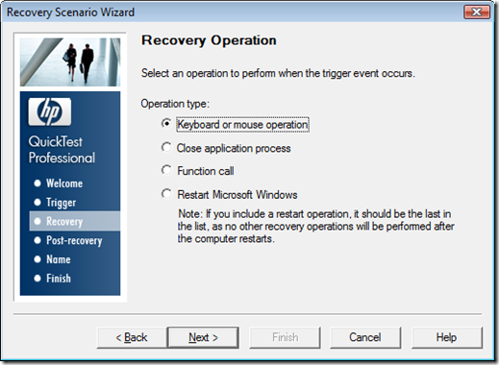](http://lh5.ggpht.com/-HrL_bPDhzBw/UbrCNPNG3NI/AAAAAAAAAgs/dLzxrnH75Fw/s1600-h/clip_image003%255B5%255D.png)

**Keyboard or Mouse Operation**

A Keyboard stroke/ Mouse click will be performed. It will be used when there is only one step operation is required. Ex: Click a button

**Close Application Process**

The specified process will be closed. It will beusedwhen any other application is interrupting execution. Ex: An antivirus system blocking execution.

**Function Call**

A library function will be called. It will be used when there are multiple steps need to be executed. Ex: When providing functional alternative, When you want to analyze the error and perform operation

**Restart Microsoft Windows**

QTP Restarts the Operating System. This will be used when the execution blocked because of a pending restart.

**Post Recovery Operations:**Recovery Operation used to clear the errors/blockers of execution. But Post Recovery Operations provide a facility on how you want to continue the execution after performing the Recovery Operation.The below are Post Recovery Operations

1. Repeat current step and continue
2. Proceed to next step
3. Proceed to next action or component iteration
4. Proceed to next test iteration
5. Restart current test run
6. Stop the test run

[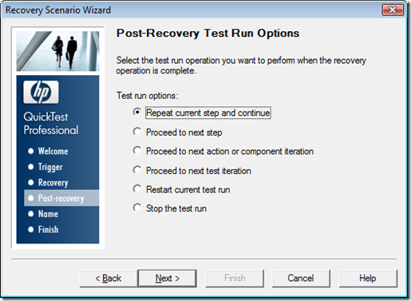](http://lh3.ggpht.com/-6aCPg2MOLFM/UbrCOJn0Z_I/AAAAAAAAAg8/EdvSkkVazm0/s1600-h/clip_image004%255B7%255D.png)

Figure 4: Post Recovery Operations

**Why Post Recovery Operations are required?**

What will happen when an Application got crashed? We will reopen the application. But how the execution will be continued? If 50 steps are executed for a script, How recovery operation will execute those 50 steps and continues the execution. No way. This type of cases we just use Restart Current Test Run as Post Recovery Operation.

So Post Recovery Operations are useful to continue the execution based on the performed Recovery Operation. It’s also useful to quit the execution in proper way.

**Repeat Current Step and Continue**

By default Recovery Scenarios will be executed when execution got interrupted due to an error. There is a facility to execute recovery scenarios for each step. I.e. whether you get error or not Recovery Scenarios will be executed. Executing them for each step will make low performance for the script and hence by default the Recovery Scenarios will be activated on error (*Observe Figure1*).

QTP understands that there is an error only when a step got failed. If that is important step and recovery operation is covering it then we choose Repeat Current Step and Continue option.

Ex: Login button got disabled QTP tries to click on it and failed. Recovery operation did something to enable Login button. QTP already executed clicking on Login button and it will try to execute next step which will become fail. In this case “Repeat Current Step and Continue” will make QTP to re-execute the clicking on login button step.

**Proceed to Next Step**

If the failed is not important or if Recovery Operation completely clears the way for execution then this option will be useful.

**Proceed to next Action or Component Iteration**

Exit from current Action iteration and starts executing next Iteration. This will be used when a Test is using Actions concept and you want to skip the only that Action iteration execution. This option is useful to execute the same Action with next set of data that is available in datatable. Component is the concept of BPT (Business Process Test).

**Proceed to next Test Iteration**

Exit from current Test iteration and starts executing next Iteration. This option is useful to execute the same Test with next set of data that is available in datatable. The above two are based Iterations concept. Please go thru below link to understand Test/Action Iterations.<http://www.qtpsudhakar.com/2009/07/test-action-iterations.html>.

**Restart current test run**

Restart the current Test Run. This option is used when there is the functional flow got disturbed and not able to continue the execution.

**Stop the Test Run**

Stops running that Test. This will be used when application is down or an open defect still there and no need to continue the execution of that test.

EXAMPLE

